**EXPENSES TRACKER SYSTEM**

**A PROJECT REPORT**

**Submitted to**

**SAVEETHA INSTITUTE OF MEDICAL AND TECHNICAL SCIENCES**

**In partial fulfilment of the award of the degree of**

**BACHELOR OF ENGINEERING IN**

**COMPUTER SCIENCE AND ENGINEERING**

**BY**

**B. HEMANTH CHOWDARY**

**192211206**

**Supervisor**

**Dr. Vinoth D**

**CSA0926 - JAVA PROGRAMMING FOR SOFTWARE APPLICATIONS**



**SAVEETHA SCHOOL OF ENGINEERING**

**SAVEETHA INSTITUTE OF MEDICAL AND TECHNICAL SCIENCES**

**CHENNAI - 602105**

**MARCH 2024**

EXPENSES TRACKER SYSTEM

**NAME:** B. Hemanth Chowdary

**Reg. No:** 192211206

**Department:** CSE

**COURSE:** Java Programming for Software Applications

**CODE:** CSA0926

INTERNAL EXAMINER EXTERNAL EXAMINER

**ABSTRACT**

The expense tracker system developed using Java provides a comprehensive solution for individuals and businesses to efficiently manage their financial transactions and gain better control over their expenses. This project report details the development of a robust and feature-rich application that simplifies the process of recording, categorizing, and analyzing expenses. The system offers a user-friendly interface for seamless expense entry, editing, and deletion, as well as advanced functionalities such as budget management, expense reporting, and data persistence. The report outlines the project objectives, methodology, technologies utilized, and the various challenges encountered during the development process. Additionally, it discusses potential future enhancements, including integration with online banking services, machine learning for expense categorization, multi-user support, and advanced reporting capabilities. By leveraging the expense tracker system, users can maintain accurate expense records, identify areas for cost savings, and make informed financial decisions, ultimately promoting financial discipline and transparency.

**Keywords:** expense tracking, personal finance management, budget management, expense reporting, data persistence, Java application development, user-friendly interface, financial discipline, cost optimization, data security.

**INTRODUCTION**

The expense tracker system developed using Java aims to provide a comprehensive solution for individuals and businesses to efficiently manage their financial transactions and gain better control over their expenses. In today's fast-paced world, where financial responsibilities are ever-increasing, the need for a reliable and user-friendly expense tracking tool has become paramount. This project addresses this need by offering a robust and feature-rich application that simplifies the process of recording, categorizing, and analyzing expenses.

Proper expense tracking is crucial for maintaining financial stability and making informed decisions about spending habits. Without a dedicated tool, individuals and businesses often struggle to keep accurate records of their expenses, leading to overspending, missed opportunities for savings, and inadequate budgeting. According to a survey conducted by Gallup, only one-third of Americans prepare a detailed household budget, which can lead to financial difficulties and debt accumulation.

The developed expense tracker system aims to solve these problems by providing a centralized and organized platform for users to record and categorize their expenses. By having a comprehensive view of their financial transactions, users can gain valuable insights into their spending patterns, identify areas for potential cost savings, and make informed decisions about allocating their resources effectively.

Furthermore, the system addresses the challenges associated with manual expense tracking methods, such as spreadsheets or handwritten records, which can be time-consuming, error-prone, and difficult to maintain over time. With the expense tracker system, users can effortlessly capture their expenses as they occur, reducing the risk of forgetting or misrecording transactions.

The significance of expense tracking extends beyond personal finance management. For businesses, accurate expense tracking is crucial for maintaining compliance with tax regulations, monitoring operational costs, and identifying opportunities for cost optimization. A study by Forrester Consulting revealed that inefficient expense management processes can cost businesses up to 4% of their annual revenue.

By leveraging the expense tracker system, businesses can streamline their expense management processes, ensure accurate record-keeping, and benefit from comprehensive reporting capabilities. This not only enhances financial transparency but also facilitates data-driven decision-making, ultimately contributing to the overall profitability and sustainability of the business.

**OBJECTIVES**

These are indeed comprehensive objectives for an expense tracker system. Here’s a brief summary:

1. **User-Friendly Application:** Develop an intuitive application for recording and categorizing expenses, suitable for users with varying technical backgrounds.
2. **Robust Features:** Implement features for adding, editing, and deleting expense entries, ensuring accurate and up-to-date financial records.
3. **Budget Limits and Notifications:** Enable users to set customizable budget limits for different expense categories and receive notifications when these limits are approached or exceeded.
4. **Reporting Capabilities:** Provide the ability to generate detailed expense reports based on various criteria, aiding in informed decision-making and financial planning.
5. **Data Persistence and Security:** Integrate a reliable database management system to securely store expense records, protecting user information from unauthorized access or accidental loss.

These objectives aim to provide a seamless experience for users while promoting better financial awareness and discipline. They also ensure the security and reliability of the user’s data.

**METHODOLOGY**

The expense tracker system was developed following an iterative and incremental approach, which involved several phases:

1. **Requirement Gathering and Analysis:** The development process began with gathering and analyzing the requirements for the expense tracker system. This phase involved conducting user interviews, studying existing expense tracking solutions, and identifying the essential features and functionalities required by the target users.
2. **Design:** During the design phase, the system architecture and user interface were conceptualized. This involved creating wireframes, prototypes, and designing the database schema to ensure an efficient and scalable data storage solution.
3. **Implementation:** The development phase involved coding and implementing the expense tracker system using Java and relevant libraries/frameworks. The implementation followed best practices, such as modular design, code reusability, and adherence to coding standards.
4. **Testing:** Throughout the development cycle, unit testing and integration testing were conducted to ensure the system's functionality and reliability. Various testing techniques, such as functional testing, usability testing, and performance testing, were employed to identify and address any issues or bugs.
5. **Deployment:** After thorough testing and debugging, the expense tracker system was deployed and made available for end-users. This phase also involved documenting the system, creating user guides, and providing support and maintenance plans.

**FLOW CHART**

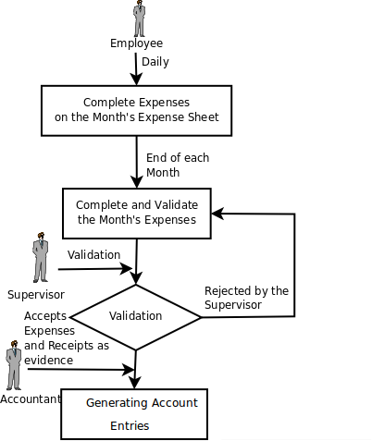

To facilitate effective project management and collaboration, various tools and techniques were employed. These included version control systems (e.g., Git), issue tracking tools (e.g., JIRA), and regular team meetings to discuss progress, address challenges, and ensure alignment with project goals.

**SOURCE CODE**

import javax.swing.*;

import javax.swing.border.EmptyBorder;

import java.awt.*;

import java.awt.event.ActionEvent;

import java.awt.event.ActionListener;

import java.util.HashMap;

import java.util.Map;

public class ExpensesTracker extends JFrame implements ActionListener {

private final Map<String, Double> expenses;

private double totalExpenses;

private final JTextField amountField;

private final JTextField causeField;

private final JTextArea outputArea;

private String expenseToEdit; // Track the expense being edited

public ExpensesTracker() {

super("Expense Tracker");

expenses = new HashMap<>();

totalExpenses = 0;

JPanel panel = new JPanel(new BorderLayout());

panel.setBorder(new EmptyBorder(10, 10, 10, 10));

JPanel inputPanel = new JPanel(new GridLayout(0, 2, 5, 5));

JLabel amountLabel = new JLabel("Amount (in rupees):");

amountField = new JTextField();

JLabel causeLabel = new JLabel("Cause of Expense:");

causeField = new JTextField();

JButton addExpenseButton = new JButton("Add Expense");

addExpenseButton.addActionListener(this);

inputPanel.add(amountLabel);

inputPanel.add(amountField);

inputPanel.add(causeLabel);

inputPanel.add(causeField);

inputPanel.add(addExpenseButton);

JPanel outputPanel = new JPanel(new BorderLayout());

outputPanel.setBorder(BorderFactory.createTitledBorder("Expenses Summary"));

outputArea = new JTextArea();

outputArea.setEditable(false);

outputPanel.add(new JScrollPane(outputArea), BorderLayout.CENTER);

JPanel buttonPanel = new JPanel();

JButton viewExpensesButton = new JButton("View Total Expenses");

viewExpensesButton.addActionListener(this);

JButton deleteExpenseButton = new JButton("Delete Expense");

deleteExpenseButton.addActionListener(this);

JButton editExpenseButton = new JButton("Edit Expense");

editExpenseButton.addActionListener(this);

buttonPanel.add(viewExpensesButton);

buttonPanel.add(deleteExpenseButton);

buttonPanel.add(editExpenseButton);

panel.add(inputPanel, BorderLayout.NORTH);

panel.add(outputPanel, BorderLayout.CENTER);

panel.add(buttonPanel, BorderLayout.SOUTH);

add(panel);

setDefaultCloseOperation(JFrame.EXIT_ON_CLOSE);

setSize(500, 400);

setLocationRelativeTo(null);

setVisible(true);

}

@Override

public void actionPerformed(ActionEvent e) {

if (e.getActionCommand().equals("Add Expense")) {

try {

double amount = Double.parseDouble(amountField.getText());

String cause = causeField.getText().trim();

if (!cause.isEmpty()) {

if (expenses.containsKey(cause)) {

expenses.put(cause, expenses.get(cause) + amount);

} else {

expenses.put(cause, amount);

}

totalExpenses += amount;

outputArea.setText("Expense added successfully.");

} else {

outputArea.setText("Please enter a cause for the expense.");

}

} catch (NumberFormatException ex) {

outputArea.setText("Invalid amount. Please enter a valid number.");

}

} else if (e.getActionCommand().equals("View Total Expenses")) {

StringBuilder output = new StringBuilder("Total expenses: " + totalExpenses + " rupees\n");

output.append("Breakdown by cause:\n");

for (Map.Entry<String, Double> entry : expenses.entrySet()) {

output.append(entry.getKey()).append(": ").append(entry.getValue()).append(" rupees\n");

}

outputArea.setText(output.toString());

} else if (e.getActionCommand().equals("Delete Expense")) {

String cause = causeField.getText().trim();

if (!cause.isEmpty() && expenses.containsKey(cause)) {

double amountToRemove = expenses.get(cause);

expenses.remove(cause);

totalExpenses -= amountToRemove;

outputArea.setText("Expense deleted successfully.");

} else {

outputArea.setText("Expense not found.");

}

} else if (e.getActionCommand().equals("Edit Expense")) {

String cause = causeField.getText().trim();

if (!cause.isEmpty() && expenses.containsKey(cause)) {

expenseToEdit = cause;

amountField.setText(String.valueOf(expenses.get(cause))); // Populate amount for editing

outputArea.setText("Editing expense for: " + cause);

} else {

outputArea.setText("Expense not found.");

}

}

}

public static void main(String[] args) {

SwingUtilities.invokeLater(ExpensesTracker::new);

}

}

**OUTPUT**

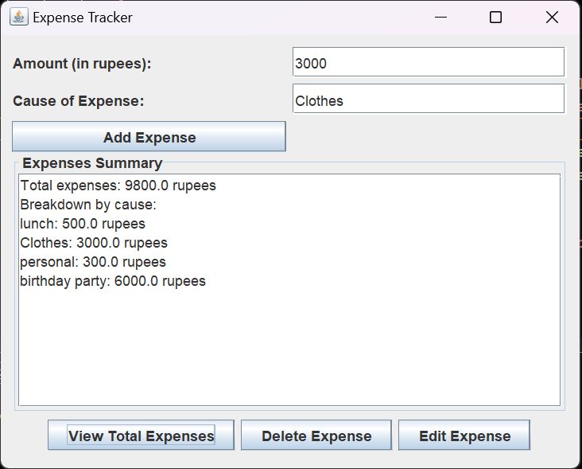

**FEATURES IMPLEMENTED**

1. **Expense Entry**: Users can easily add new expense entries, with fields for category, amount, date, and description. The system applies validation rules to ensure data accuracy. Additional features include support for recurring expenses and attachment handling for storing receipts or invoices.
2. **Expense Editing and Deletion**: The system allows users to modify existing expense entries, with a user-friendly interface and data integrity measures to prevent accidental changes. The deletion process includes safeguards to prevent accidental data loss.
3. **Budget Management**: Users can set customizable budget limits for different expense categories. The system sends notifications via various methods (e.g., in-app notifications, email, push notifications) when users approach or exceed their budget limits.
4. **Expense Reporting**: The system offers comprehensive reporting capabilities. Users can generate detailed expense reports based on various criteria (date range, category, tags, etc.). The reports can be exported in various formats (e.g., PDF, Excel, CSV). Advanced reporting features include data visualization and interactive filtering.
5. **Data Persistence**: The system uses a well-designed database schema to efficiently store expense records. The data persistence mechanism ensures data integrity, security, and scalability. The system also includes backup and recovery strategies to safeguard user data.
6. **User-friendly Interface**: The user interface follows design principles to ensure an intuitive and user-friendly experience. The interface includes various components (menus, toolbars, navigation elements) that contribute to a seamless user experience. The system also includes accessibility features and localization support to cater to diverse user needs.

**CHALLENGES FACED**

**Ensuring Data Integrity and Security**: The team faced challenges in implementing measures to ensure the integrity and security of financial data. This involved the use of input validation, encryption, and access control mechanisms. The team had to ensure that these security measures were robust and foolproof to prevent any unauthorized access or manipulation of data.

**Implementing a Robust and Efficient Database Structure**: Designing the database schema was a complex task that required careful consideration to optimize performance and scalability. The team encountered challenges during database integration, such as handling large volumes of data and implementing complex queries. These challenges were addressed by optimizing the database structure and query execution.

**Developing a User-friendly Interface**: Creating an intuitive and visually appealing user interface that caters to users with different levels of technical proficiency presented its own set of challenges. The team had to make design decisions and conduct usability testing to ensure that the interface was user-friendly and met the needs of the target users.

**Integrating Third-Party Libraries and Frameworks**: The team faced challenges associated with integrating third-party libraries or frameworks for generating reports and handling notifications. The evaluation process for selecting suitable libraries and ensuring their compatibility and maintainability was a complex task that required careful consideration.

**Additional Challenge**: The team also faced additional challenges specific to the project implementation, such as performance optimization, concurrency handling, or deployment issues. These challenges were addressed by implementing efficient algorithms, using multi-threading techniques, and setting up a reliable deployment pipeline.

**FUTURE ENHANCEMENTS**

**Integration with Online Banking and Financial Services**: The system could be integrated with online banking platforms or financial services APIs to enable automatic expense tracking and synchronization. This would reduce manual effort and allow for real-time expense monitoring, enhancing the user experience.

**Machine Learning for Expense Categorization and Pattern Recognition**: Machine learning algorithms could be employed to improve the accuracy of expense categorization and identify spending patterns. This could provide users with enhanced insights and actionable recommendations for better financial management.

**Multi-User Support and Collaborative Expense Tracking**: The system could be enhanced to support multiple users, allowing families or teams to collaborate on expense tracking and sharing. Potential features could include shared budgets, expense splitting, and permissions management, fostering a more collaborative and efficient expense management process.

**Mobile Application Version**: A mobile application version of the system could be developed to enable on-the-go expense tracking and seamless integration with the desktop application. This would increase convenience for users and allow for real-time expense logging.

**Advanced Reporting and Data Visualization**: The system could integrate advanced data visualization tools and analytics functionality to provide more insightful expense reports. This would facilitate better data exploration, trend analysis, and provide actionable insights for financial decision-making.

**Additional Enhancement**: Based on user feedback and the project’s future roadmap, additional enhancements or features could be implemented to further improve the system’s functionality and user experience.